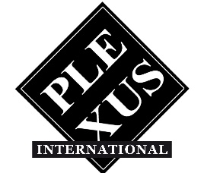PLEXUS INTERNATIONAL FORUM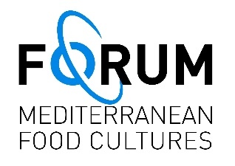
Via Giovanni Pascoli 6, Sorano (GR)
www.plexusinternational.org / www.medfoodcultures.org

The journey of Plexus International resumes from Sorano, MaremmaTuscany, Italy.
In August 2024, the legal headquarters of Plexus International Forum APS ETS, a social promotion association, was opened in Sorano (GR), functioning as the operational and administrative tool of Plexus International and the Forum on Mediterranean Food Cultures.

In a global world where diverse values and cultures increasingly clash, the activities of Plexus International Forum in Sorano will focus on creating new creative connections within various communities, often very close to one another but frequently not communicating, where art and culture can become important community resources for sustainable environmental, economic, and sociocultural development.

Plexus International aims to promote a shift in awareness and perception of art and culture as sustainable human resources, vital for our evolution and survival on the planet.
The Official Archives of Plexus International, meticulously documenting its activities from 1982 to 2024, have been transferred from Rome to Sorano, along with their collection of original documents and certified original Plexus artworks, including the Plexus Metr'Art, a monumental contemporary artwork stretching 390.94 meters, created from 2004 to 2019, comprising 935 contributions from 469 artists worldwide.

The Plexus digital archive hosts over 25,000 photographs and more than 170 videos on the Plexus YouTube channel. The full activities of Plexus International can be found at www.plexusinternational.org.
Additionally, comprehensive documentation of the activities of the Forum on Mediterranean Food Cultures on sustainable food systems and the Mediterranean diet as a model of sustainable eating is preserved. From 2016 to 2022, three global conferences were co-organized to revitalize the Mediterranean diet as a community resource for sustainable development—environmental, economic, and sociocultural. The full activities of the Forum can be found at www.medfoodcultures.org.
The Archives of Plexus International at Plexus International Forum APS ETS, Via Giovanni Pascoli 6, Sorano, are open for consultations by appointment (email: info@plexusinternational.org). Visitors can also enjoy stays at the DJOUR'S Guest House, on-site, by reservation.

Over 1,000 artists have participated in the journey of Plexus International (musicians, poets, visual artists, performers, dancers, theater actors, playwrights, academics, and community activists), interacting with each other in various parts of the world through unifying metaphors and myths. At the end of events, ritual group photographs were taken of participating artists holding photographs from previous events, a deliberate action of artistic compression of hundreds of recognizable faces of other artists, symbolically united together in the art journey of Plexus International.
Plexus International was founded in New York in 1982 by a heterogeneous group of artists within that engaging and experimental participatory cultural environment of the 1980s, seeking an alternative to the dynamics of the art market. It is currently present in the Medina of Dakar, Rome, Cagliari (Sardinia), Cairns (Australia), New York, and now in Sorano.
Since 1985, Plexus Art-Co-Operas have enabled interdependent creative interactions within an eclectic mix of concepts, artistic expressions, scientific notions, disciplines, languages, cultures, and geopolitical contexts, facilitating individual energies to express themselves collectively in the perception and awareness of our shared existence on planet Earth. A shift in awareness about the value of art and culture as nourishment for our evolution and survival.
Since 1987, Plexus International, with the Art Co-Opera “Stone Serpent,” has conducted the first exchanges of digital art, facilitated by the Digital Art Exchange DAX Group at Carnegie Mellon University and the Department of Physics at the University of Cagliari, before the advent of the internet, and has continued to explore the evolution of new communication media to encourage new experimental artistic interactions.
From 2004, the Plexus Open Calls accompanying the traveling international event Erosions and Renaissance have raised awareness of the increasing global and interdependent challenges we face today: climate change, exploitation of the planet's natural resources and human beings, loss of biodiversity and cultural diversity, human rights, injustice, poverty, hunger, wars, peace, and freedom.
In 2008, Plexus International launched the “Appeal for the Safeguarding of the Cultural and Natural Heritage of Humanity” from the Door of No Return of the House of Slaves in Goree, Dakar, as a symbol of the erosion of humanity's historical memory.
From 2004 to 2019, the monumental Plexus Metr'Art, measuring 390.94 meters, was created with reproductions of 935 digital artworks submitted by 469 artists from around the world.
The artistic journey embarked upon by Plexus International aims to create a new “art environment” where artists act as independent producers of their “Art Co-Opera,” co-created through a modular construction built by the artists themselves, as primary consumers of their artistic contributions and simultaneously co-producers with other artists in the Art Co-Opera, carving out a shared, yet unexplored space-time of art, science, and digital communication technologies. This has been part of the global and participatory journey undertaken by Plexus International for over 40 years without interruption.
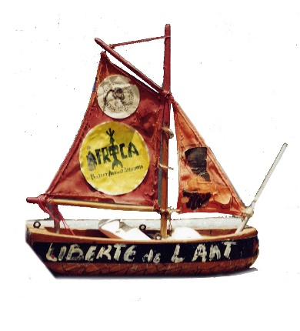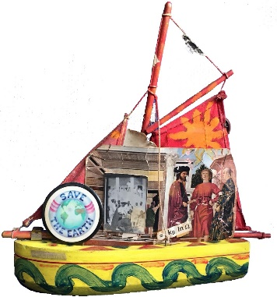The Voyage Continues…

