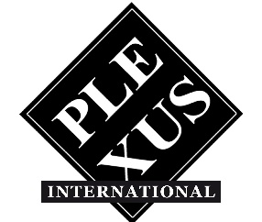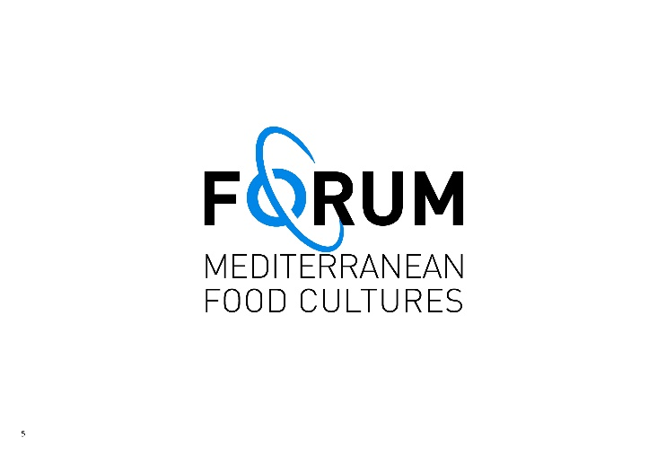

Plexus International was established in the Eighties by a heterogeneous group of artists, within that exciting and experimental participative cultural environment of the 1980’s by seeking an alternative to the dynamics of the Art market.

Plexus has directed its activities since its inception in 1982, in New York, to create an open artists participative community environment “Plexus Art-Coperas”, through a joint co-development process co-designed by the artists themselves, participating in the first person as independent producers of their art contributions to the International Plexus process, carving out a unique and unexplored joint art&science and technologies space-time.

Through the realization of numerous collaborative international events, the Plexus Art Co-Operas, over 1,000 artists have participated in the journey of Plexus International, including musicians, poets, visual artists, performers, dancers, theater actors, playwrights, academics, and community activists, who have interacted with one another across different parts of the world, symbolically united through group photo rituals of the participants at the end of the event holding pictures of previous group shots, featuring compressed hundreds and hundreds recognizable faces.

Since 1987, Plexus, with the Art Co-Opera “Serpente di Pietra,” has realized early exchanges of digital art, facilitated by the Digital Art Exchange DAX Group of Carnegie Mellon University and the Department of Physics of the University of Cagliari, before the birth of the internet, and has continued to explore the evolution of new communication mediums to encourage new experimental artistic interactions.

Since 1985, Plexus Art-Co-Operas have made possible creative interdependent interactions within an eclectic mix of concepts, artistic expressions, scientific notions, disciplines, concepts, languages, cultures and geopolitical contexts, facilitating individual energies to express themselves collectively for a “change of route” in perception and awareness of our common living in the planet Earth, with critical interdependent global challenges that we are facing today, such as: inclusion, human rights for all, injustice, exploitation of human beings and natural resources, climate change, loss of biodiversity, cultural diversity and freedom and peace.

In 2008, Plexus International launched with the event “Erosions and Renaissance” the Call for the Safeguarding of the Cultural and Natural Heritage of Humanity from the Door of No Return of the House of Slaves in Goree, Dakar, as a symbol of the erosion of humanity's historical memory and new contemporary forms of slavery in the world.

The Plexus International Archives, managed by Plexus International Forum non for profit organization, preserve a vast collection of original documents, certified original Plexus artworks, such as the Plexus Metr'Art of 390.94 meters, created between 2004 and 2019, including 935 contributions from 469 artists worldwide, as a symbolic tool of metaphorical measurement within the traveling artistic project “Erosions and Renaissance.” Furthermore, the Plexus Web Gallery’s digital archive houses more than 25,000 photographs and over 170 videos on Plexus’s YouTube channel.

In 2024, Plexus International transferred from Rome its Official Archives meticulously documenting its activities from 1982 to 2024, to Sorano, in Maremma Tuscany, at the new headquarters of the Plexus International Forum Onlus not for profit Association, the operational and administrative tool of Plexus International and of the Forum on Mediterranean Food Cultures, as a programme.

Plexus International is a vibrant presence in the Medina of Dakar, Rome, Cagliari (Sardinia), Cairns (Australia), New York, and now in the medieval borgo of Sorano (Tuscany).

In a global world where diverse values and cultures increasingly clash, Plexus International continues its artistic journey from Sorano with a commitment to promote a change in the perception and awareness of our shared existence on planet Earth, with particular attention to creating connections between communities, often very close to one another but not communicating, where art and culture can be an important resource for sustainable community development, an indispensable food for our evolution and survival.

Plexus International journey “Erosions and Renaissance” continues from Sorano, by joining a community participative effort to stop the Sorano Wind Park Project, currently under approval, and to engage everyone within this collaborative community project of creativity.

The Plexus International Archives at Plexus International Forum APS ETS,
Via Giovanni Pascoli 6, Sorano, are open for consultations by appointment
(email: info@plexusinternational.org).
Guests can also enjoy stays at the DJOUR'S Guest House upon reservation.

More info: www.plexusinternational.org; www.medfoodcultures.org
email: info@plexusinternational.org

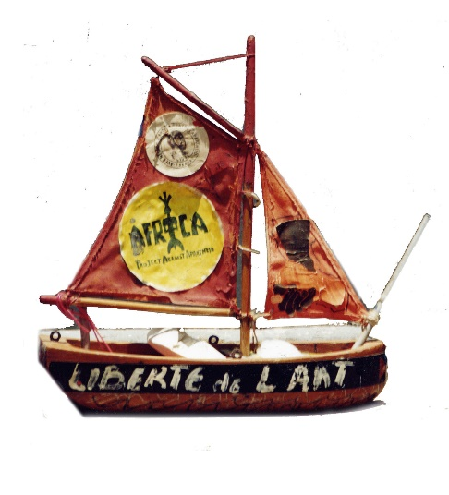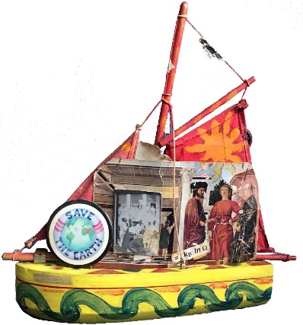

THE VOYAGE CONTINUES…IN ORDER TO SURVIVE

